Test Cases for Assignment 1 (Part 1)

# **Part 1 Test cases:**

* **Valid Cases:**

1. **823 + -145**

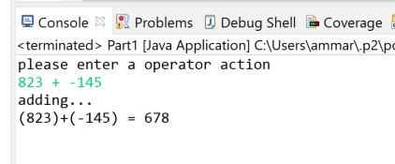

1. **-23 + -245**

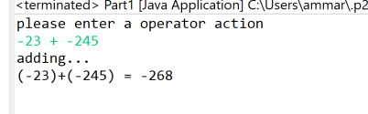

1. **-23 *-45**

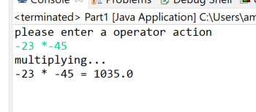

1. **-23 / -345**

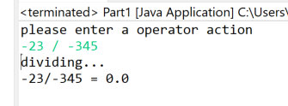

1. **-23 --45**

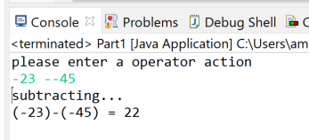

* **Non Valid Cases**

1. **--23 + 45**
2. **-23 +* 45**
3. **-23 +/ 45**

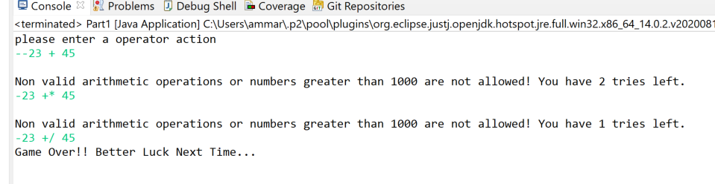

1. **-23 -/ 45**
2. **-23 */ 45**
3. **--23 */-45**

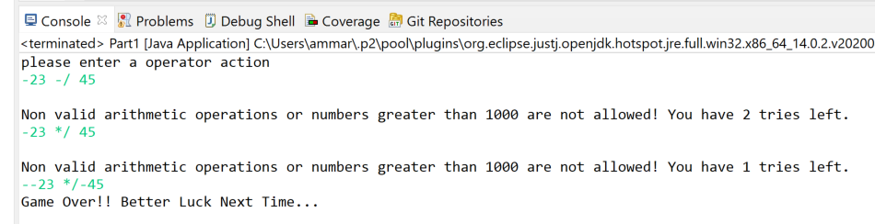

1. **23 ++45**
2. **23 **5**

**9) 23 // 42**

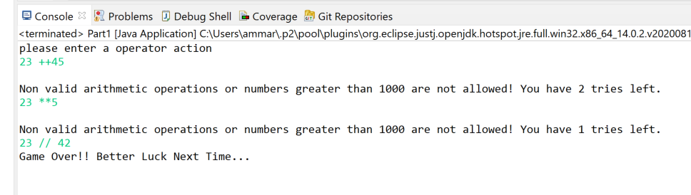

**How about cases such as the following**

1. **23 a-56**
2. **23 + 67i**
3. **-j33 +98**

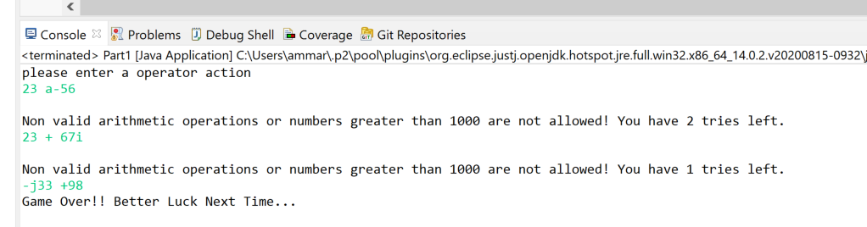

1. 1
2. 1%1
3. -1++

